**REST - Country Web Service**

**Step 1:**

Create a Maven project using <https://start.spring.io/> along with the dependency spring web tools.

**Step 2:**

Create a folder called model in src \ main \ java \ com \ cognizant \ spring-learn1 and create a file called Country.java and write the following code

package com.cognizant.spring_learn1.model;

public class Country {

private String code;

private String name;

public Country() {}

public Country(String code, String name) {

this.code = code;

this.name = name;

}

public String getCode() {

return code;

}

public void setCode(String code) {

this.code = code;

}

public String getName() {

return name;

}

public void setName(String name) {

this.name = name;

}

}

**Step 3:**

Create a controller folder in src \ main \ java \ com \ cognizant \ spring-learn1 and create CountryController.java and write the following code:

package com.cognizant.spring_learn1.controller;

import com.cognizant.spring_learn1.model.Country;

import org.slf4j.Logger;

import org.slf4j.LoggerFactory;

import org.springframework.context.ApplicationContext;

import org.springframework.context.support.ClassPathXmlApplicationContext;

import org.springframework.web.bind.annotation.RequestMapping;

import org.springframework.web.bind.annotation.RestController;

@RestController

public class CountryController {

private static final Logger LOGGER = LoggerFactory.getLogger(CountryController.class);

@RequestMapping("/country")

public Country getCountryIndia() {

LOGGER.info("START");

ApplicationContext context = new ClassPathXmlApplicationContext("country.xml");

Country india = context.getBean("in", Country.class);

LOGGER.info("END");

return india;

}

}

**Step 4:**

In the src \ main \ resources create the file country.xml and write the following code:

<?xml version="1.0" encoding="UTF-8"?>

<beans xmlns="http://www.springframework.org/schema/beans"

xmlns:xsi="http://www.w3.org/2001/XMLSchema-instance"

xsi:schemaLocation="http://www.springframework.org/schema/beans

https://www.springframework.org/schema/beans/spring-beans.xsd">

<!-- Country Bean for India -->

<bean id="in" class="com.cognizant.spring_learn1.model.Country">

<property name="code" value="IN"/>

<property name="name" value="India"/>

</bean>

</beans>

**Step 5:**

Next , run the SpringLearn1Application.java as such

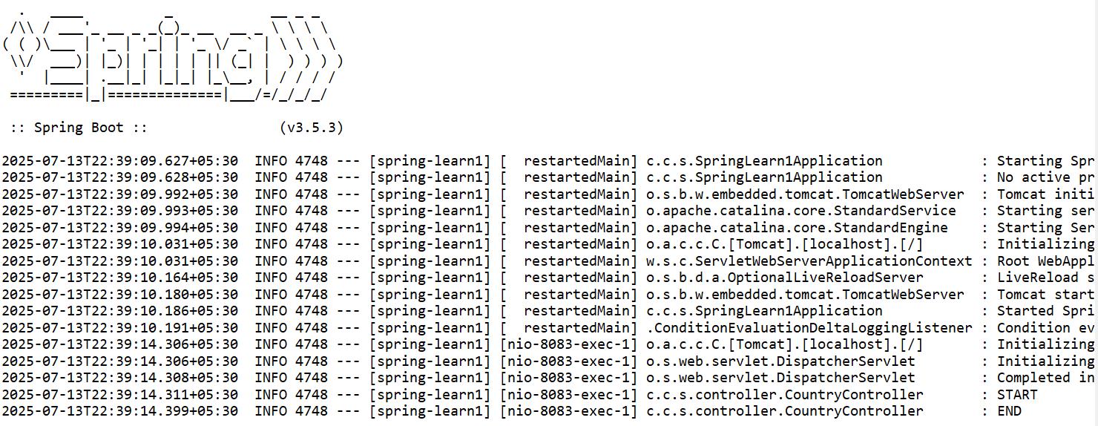

**Output:**

Open a browser and run <http://localhost:8083/country>

